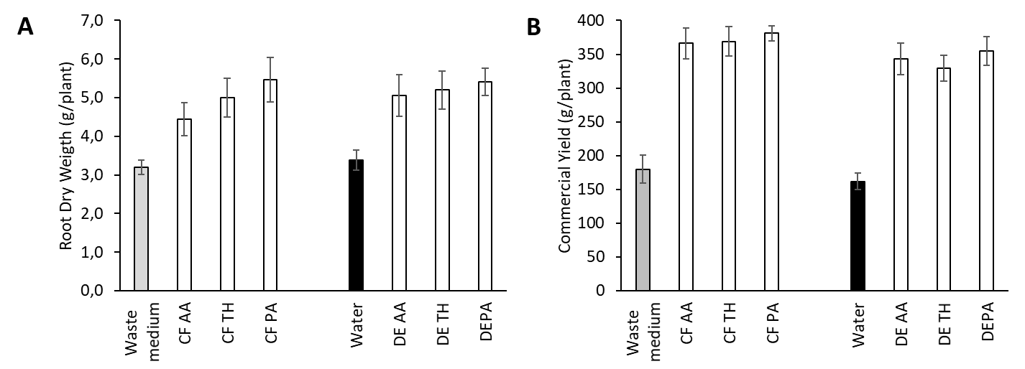

**Irrigation with cell-free fungal cultures and distillates obtained from fungal cultures increase root growth (A) and commercial yield (B) in pepper plants (cv. Sweet italian) under greenhouse conditions.** Pepper plants were irrigated with cell-free filtrates (CF) or distillates (DE) from a plant growth promoting fungus (*T. harzianum* (TH)) and two fungal phytopathogens (*A. alternata* (AA) and *P. aurantiogriseum* (PA)), while controls were irrigated with wasted medium and water, respectively. Values are the means ± SE obtained from analyses of sets of 12 independent plants. Data from [Baroja-Fernández et al., 2021](https://www.frontiersin.org/articles/10.3389/fpls.2021.752653/full).

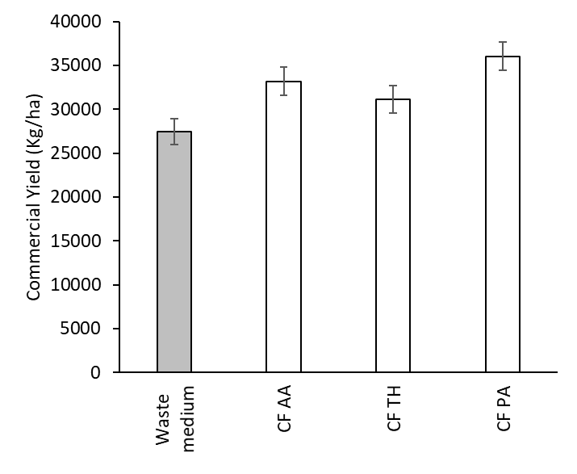

**Irrigation with cell-free fungal cultures increase commercial yield in pepper plants (cv. Piquillo) in open field.** Pepper plants were irrigated with cell-free filtrates (CF) from a plant growth promoting fungus (*T. harzianum* (TH)) and two fungal phytopathogens (*A. alternata* (AA) and *P. aurantiogriseum* (PA)), while controls were irrigated with wasted medium. The results are the mean ± SE of 210 plants per treatment. Data from [Baroja-Fernández et al., 2021](https://www.frontiersin.org/articles/10.3389/fpls.2021.752653/full).

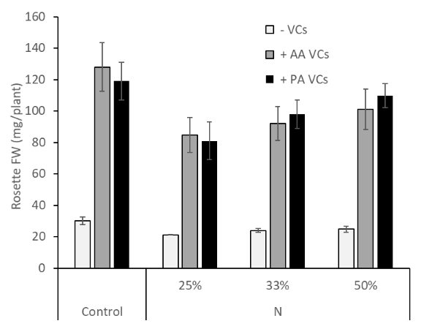

**Volatile emissions of *P. aurantiogriseum* and *Alternaria alternata* improve plant growth in nutrient-deficient medium.** Fresh weight of Arabidopsis plants grown in the absence or continuous presence for a week of adjacent cultures of *P. aurantiogriseum* (PA) or *A. alternata* (AA) and in complete (control) and N-deficient medium for 14 days. Seeds were germinated on ½ MS medium for a week and then transferred to complete or deficient ½ MS medium for another week before exposure to fungal volatiles (VCs). Results are the means ± SE obtained from analyses of 18 plants per treatment.

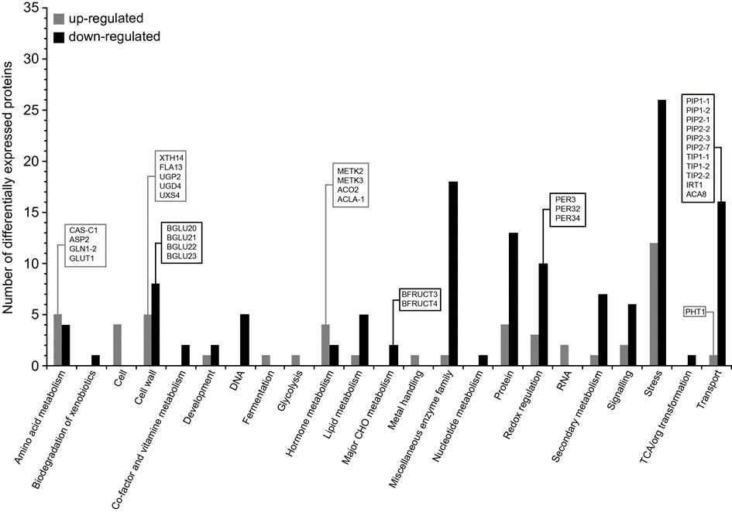

**Functional characterization of differentially expressed proteins in roots of Arabidopsis plants cultured in the presence of VCs emitted by *P. aurantiogriseum*. The proteins that were significantly down- and up-regulated** following VC exposure were sorted according to functional categories assigned by MapMan software. Gray and black bars indicate numbers of up- and down-regulated proteins in each category, respectively. Data from [García-Gómez et al., 2020](https://onlinelibrary.wiley.com/doi/abs/10.1111/pce.13817).